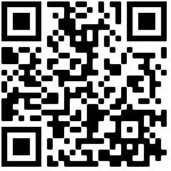
Camp Participant Forms Required Information
Camp Participant Form Link: https://www.studentlife.com/prepcenter/parent

Your Camp Type (REC, MISSION, BEACH, FLEX):

REG ID (optional):

Camp Location & Date:

Church Name & Address:

Group Leader Name & Email Address:

