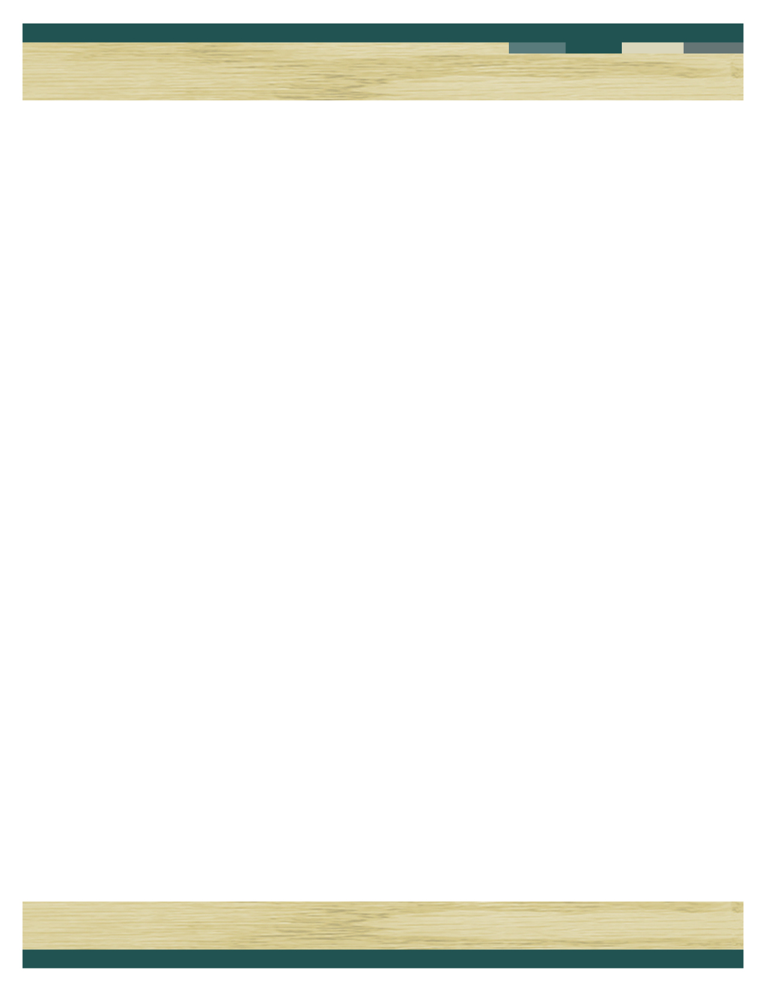

Make all checks payable to **MYRTLE BEACH CONVENTION CENTER**

**For any questions call Chris Lindstrom at 843-447-9555**

**THANK YOU FOR YOUR BUSINESS! City, ere. .com OM**

Myrtle Beach Convention Center Concessions

2101 N Oak St

Myrtle Beach, SC 29577

Office 843-918-1238

Phone 843-447-9555

clindstrom@cityofmyrtlebeach.com

|  |  |  |  |
| --- | --- | --- | --- |
| Quantity | Description | Unit Price | Total |
| _________  _________  _________  __________ | Ham Sub- chips, cookie, drink  Turkey Sub- chips, cookie, drink  PB&J – chips, cookie, drink  Chopped Salad- Fruit, snack, drink  All orders have choice of bottled water, Pepsi, Diet Pepsi, or Sprite can.  Tax is included in price. | $8.50  $8.50  $8.50  $8.50 |  |
| TOTAL AMOUNT DUE | | |  |

**NOTE: One week before event 2022 is the last day that lunch orders can be placed. None will be accepted at a later time.**

|  |  |  |  |  |  |
| --- | --- | --- | --- | --- | --- |
| Contact person |  | Phone # |  | Time of lunch |  |
|  |  |  |  |  |  |

Credit Card Payment: Visa Mastercard Discover

Name on Card:

Card #:

Exp Date: 3 Digit on back

Authorized Signature:

**Order For:**

**Lunch options**

LUNCH 19